**Task 1: AWS S3 Setup Guide**

Step 1: Create an AWS Account

Visit the AWS Management Console.

Sign up for a new AWS account if you don’t already have one.

**Step 2: Open the S3 Service**

Once logged in, type “S3” in the AWS services search bar.

Select S3 from the list to open the service dashboard.

**Step 3: Create a New S3 Bucket**

Click “Create bucket”.

Provide a unique bucket name (e.g., my-example-bucket-<your-unique-id>).

Choose an AWS region that is geographically close to you.

Under Block Public Access settings, optionally uncheck “Block all public access” if you want to make your bucket public.

Click “Create bucket” to complete the setup.

**Step 4: Upload Sample Files**

Open the newly created bucket.

Click “Upload”.

Add files by either dragging and dropping or clicking “Add files” to choose from your computer.

Press “Upload” to start uploading your files.

**Step 5: Set Access Permissions**

Select the uploaded files.

Open the “Actions” menu and choose “Make public” if you want the files to be publicly accessible.

For more control, you can also configure access using Bucket Policies or IAM Roles.

**Step 6: Confirm Access**

To test, go to the public URL of your file, for example:

http://my-example-bucket-<your-unique-id>.s3.amazonaws.com/

If everything is set up correctly, your files should be viewable in the browser.

Created Bucket s3

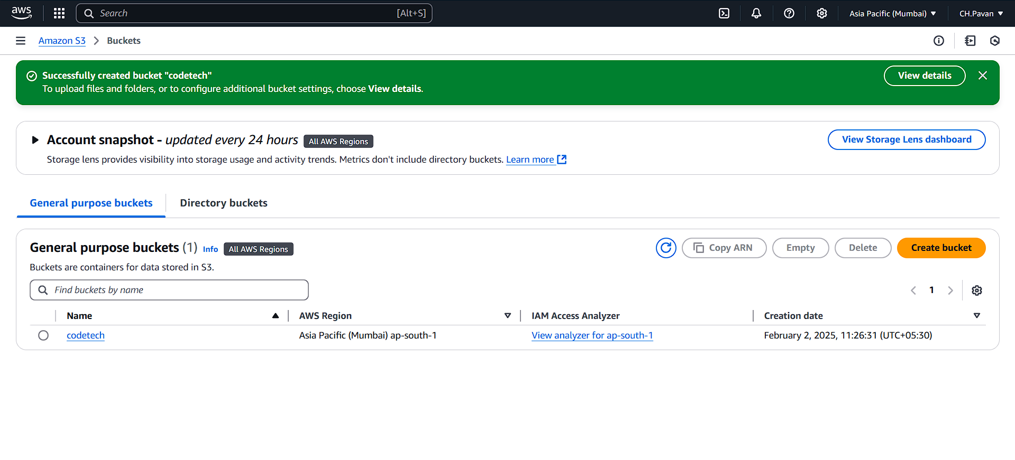

Upload files

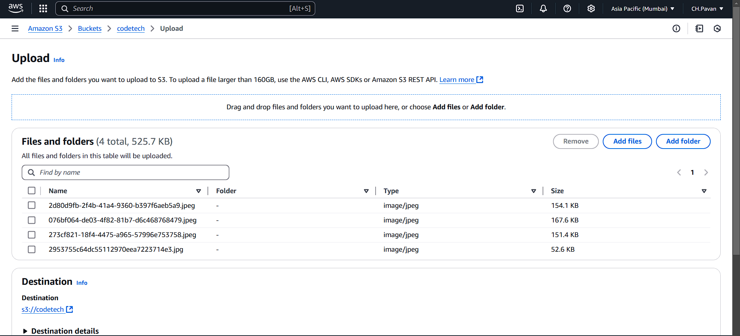

Access Control settings

Objects deleted

Deleted bucket

